Tell me about your self:

GM/GA/GE, Thanks a lot for short listing me /giving me this opportunity to talk about myself. I am Fouzia Javeed. I am having an overall experience of about 8+yrs in IT .I started my career as a Business Analyst in Convergys – Telecom domain . And for the past 4 years I have been working as QA at hertz inc. making significant inroads into the new territories with our products. I have worked intensively in both Automation as well as manual testing (70-80%-automation n 20-30 % manual). I am pretty much comfortable with manual testing, designing n writing the test cases, bug life cycle, defect life cycle, and test prep n test plan, which involves basically in the functional n manual testing. Our team was one of the best team which have closely worked with the clients and built some strong relationships.

During the work breaks , I enjoy ……

I am a person who thrives in a fast paced environment n very versatile, easy going, open minded, solution oriented, determined team player, very creative and enjoy working with others.

With my passion for testing and my skill sets for automation and integration tools, I wish to work for the leading, innovative company like yours and I strongly believe I can make a positive impact

Read the job description ,sound enthusiastic about the position

Microsoft Visual Studio Team Services (VSTS) is a new cloud-based offering that helps the project teams to take care of all the aspects of the process for software development.

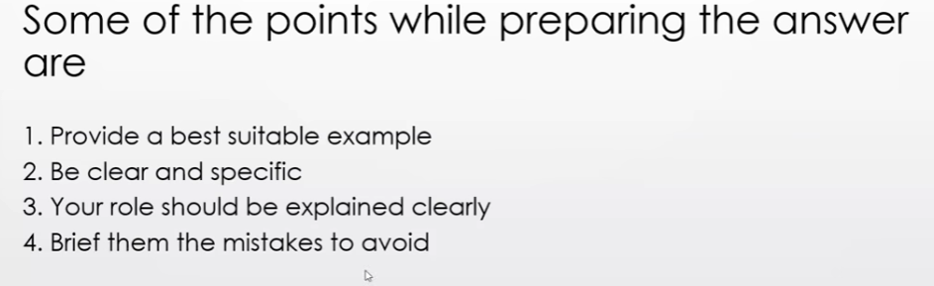

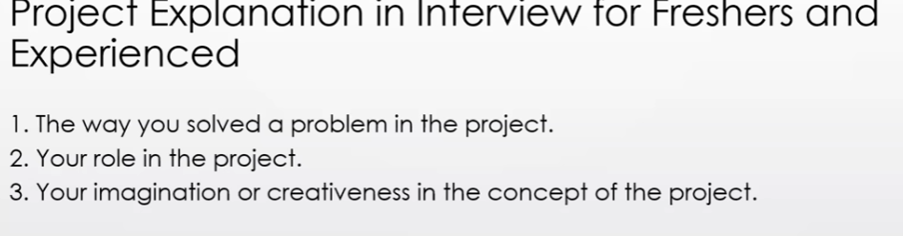

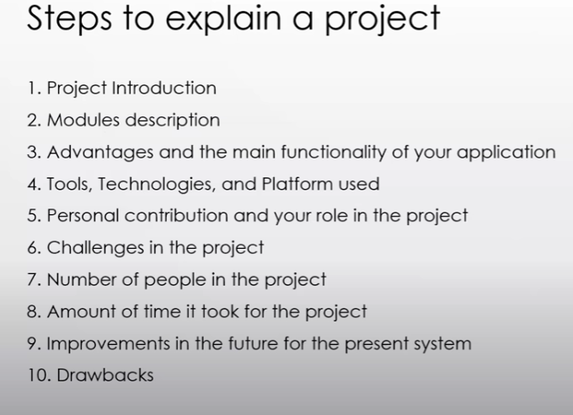

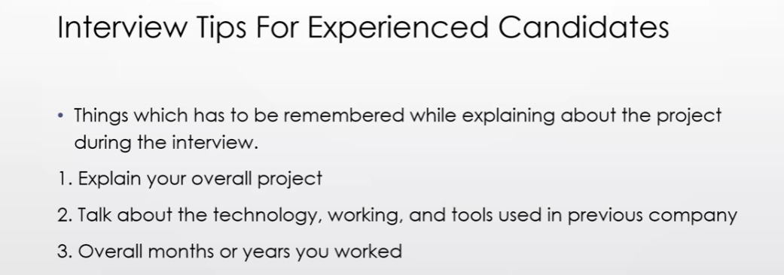

Naveen : <https://www.youtube.com/watch?v=x9vAgJSq2O0>

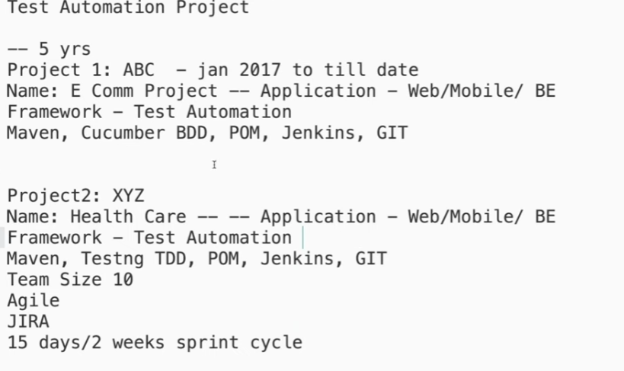

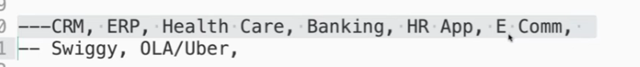

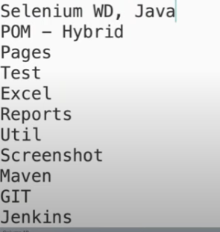

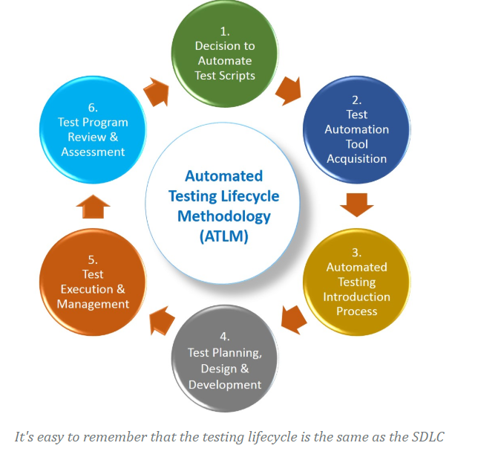

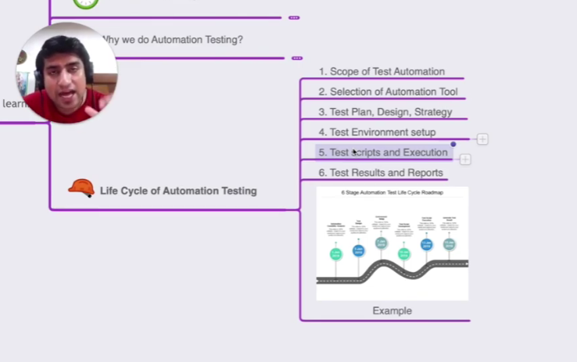

The project for the ecommerce :

3 layers :

1t layer wchihc is UI(front end), 2nd layer is the database and 3rd layer is the inventory layer where we generate the invoice.

My project has home page , product details page,add to cart page billing n shipping page and then the payment page .

If we want to buy a product , we need togo to the product page and select the product where we have many filters to apply like size , color,brand filter .Select all the filters and then click on the product to buy. In add to cart , we have diff options like continue shopping , delete already selected product. And then proceed to checkout page where we have to provide the billing and shipping details.Then in the payment page , we have multiple channels of payment like net banking , credit card, debit card, COD, other integratrions etc. We select one of the payment mode and then the product is purchased.Now there are other integrations that whenever a customer buys product the email will be send to them about the purchase and invoice of the product .

Tools -Technologies: With respect to automation I am having very good exposure on the automation tools and technologies. I am very much comfortable with open source as well as licence based technologies. Started my career with QTP…But from last 4-5 years majorly ,I am inclined towards open source tech like selenium,JMeter,Rest assured API.

Very good exposure in deigning the framework from scratch as well as upon the existing framework.I am pretty much comfortable with the different framework approaches like Data driven,KWD ,Hybrid framworks, exposure on Page object models in selenium. I started working with Selenium RC and Recently I am using selenium Web driver 3.141.59 and now the latest version in the market is Selenium 4

I am currently working with selenium Web driver component , although I am comfortable with all the components of Selenium …IDE, Grid, RC ,Web driver…I don’t prefer selenium RC as its totally deprecated and I am using selenium Webdriver . My most preferred language is java always although I have some basic knowledge on Ruby,Python,JS. But most of the time I am using selenium with Java. I have very good exposure on BDD frameworks like Cucumber ,

Good exposure on CI tools like Jenkins ,Maven, build automation tool like Maven. I am pretty much comfortable in designing the framework components end to end.

Project Roles and responsibilities:

Flipkart is an ecommerce company

Banking appl, mobility services like OLA,UBER,

Health care;

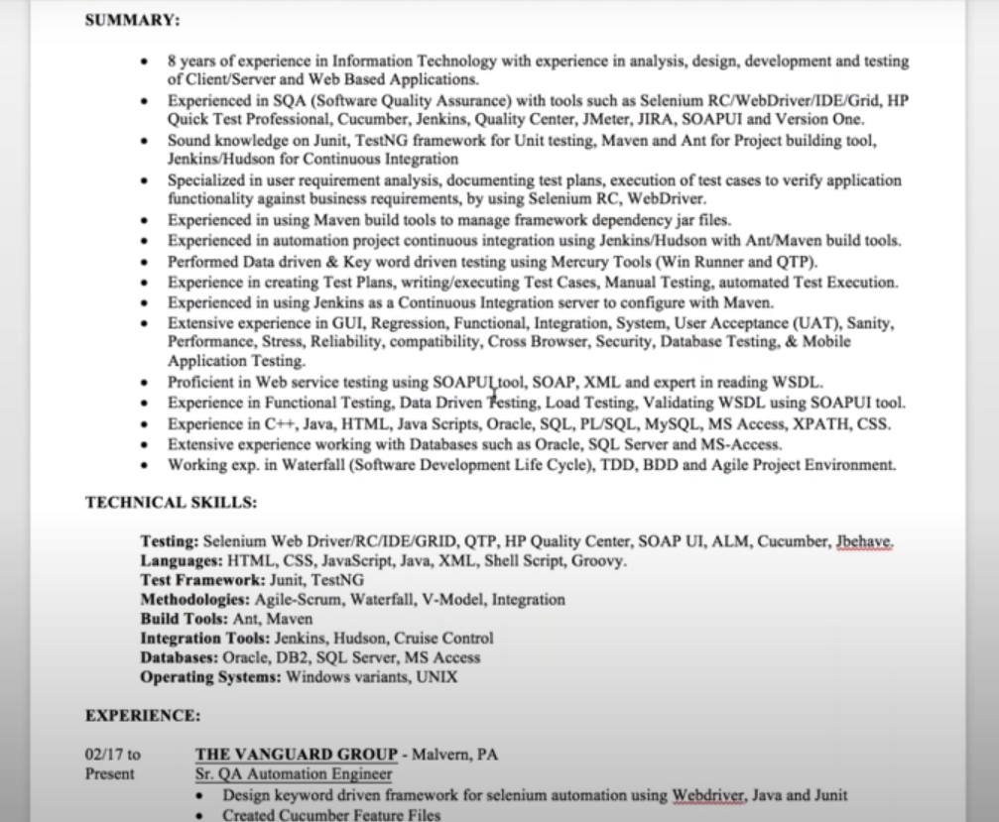

Current roles:

I am involved into the backend automation as well as front end automation.

Front end automation, we are using the Selenium webdriver grid with java language binding. (don’t say eclipse). From the backend .I am pretty much comfortable with java and all the object oriented concepts, selenium and the concepts of selenium.I am also responsible for designing the framework .

Initially while designing the framework there were lot of challenges and I accepted all the challenges and gave the POC(proff of concept )/demo to management and we were the part of the agile team and then the part of automation.So far we have achieved upto 75-80 % automation.Out of 500 test cases we have automated all together 430 cases. Initially there were lot of manual test cases and we picked up and converted into the automation test cases. That was my roles and responsibility.

Also we were involved into the backend automation activities where we were using the rest assured and htp protocol services due to lot of API’s.

Previous projects:

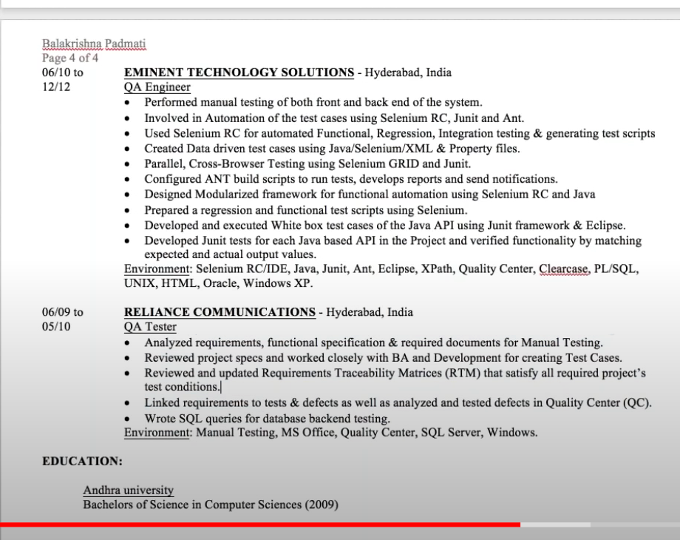

So why do u want to join: (8 yrs)

In the next two three years, I am looking for the company where I get that kind of environment to implement the things which I have learnt so far through out my career. I can mentor/lead a team or as an individual contributor I can perform some amazing stuff in terms of automation so that we can save our resources, cost etc.

4-5 yrs

They are still couple of things I want to learn, I have that learning attitude and I am very quick learning n hard working n knowledge sharing. Whatever things I have in my pocket Ill share with others. As sharing is caring.

Project and accepted the position.

This will be one of my best opportunity to have and the best challenge to accept. This is the kind of env and the skill set I was looking for. And similar kind of things I was looking in my portfolios. If I join ur team n ur company def it will be great value addition in my profile also..

Appreciate the interviewer …no one would get the ego problem and not reject

I want to join this company coz I want to learn something new from this company and u r doing some amazing things here and def I would like to be part of ur team so that we can work together and then improve the things and achieve the target on time.

Comfortable to mentor the previous employees. I am very good in knowledge sharing with juniors as well as accept new challenges from others be it the juniors or seniors,…and it doesn’t matter if they are my juniors .I don’t have the attitude that I cant learn from the juniors.

How do u update from the latest tech n hobbies?

I want to grow more technically. I follow a lot of new blogs, channels, technically you tube automation videos.

What the guarantee that u r going to join us:

Major challenge:

Identify the right/main components which will fulfill our current as well as our future req.

Future req means we need to think just not for the current but also for the future where there will be more chances to expand as in integrate with more parties. When designing the framework, we always need to think about the future visibility to enhance the framework, challenges which may come to handle the framework.

Main challenge to write the libraries, page functions, listeners classes’: like making the functions static private and final. We need to think of all the points while designing framework coz in future if we need to make any enhancements, our script should be compatible enough to take that changes. We shouldn’t hard code the values. We have used the Source code management tool like git repo.

We can push pull merge the code, resolve the conflicts, checkout the projects in git.

In my company , we follow agile methods and small teams who contributes and is reposnsible for the functional ,performance and automation . in my scrum team we have 7 members where there r 2 QA/testers whose responsibility is starting from the functional testing to automation to performance and finally deliver the product to the market.

How many browsers u have covered.\

Mostly covered chrome and sometimes firefox.

Have u used the grid…

The advantage of Gird is that we can run test cases parallelly in many diff browsers..In our company we don’t have the grid concept coz we used to trigger our scripts through Jenkins. We had two VM’s , in one VM we used to run the script through firefox and in other we run through chrome.We hardly had one VM or max two and the grid will come into picture where we have multiple servers associated with master computers which in turn will command the slave systems so that test cases gets executed.

How many scripts do we automate in a day:

It depends on the scenario, when we do the end to end scenario , it can take more than one day.It also depends on how good the framework is. If we have all the page libraries ready, all the methods are ready, we can do 10-15 test cases. When its UI verifications , we can easily do 15 test cases but when scenario comes into picture we cannot do more than 3 scripts.

How many scripts u automated till date:

The automation all depends on how much time we’re reducing to do regression testing. ‘whenever there is new release we run the automation to make sure that there is our existing functionality is not breaking hence saving the time. For 3 yrs of experience , we can say we automated around 3200 scripts

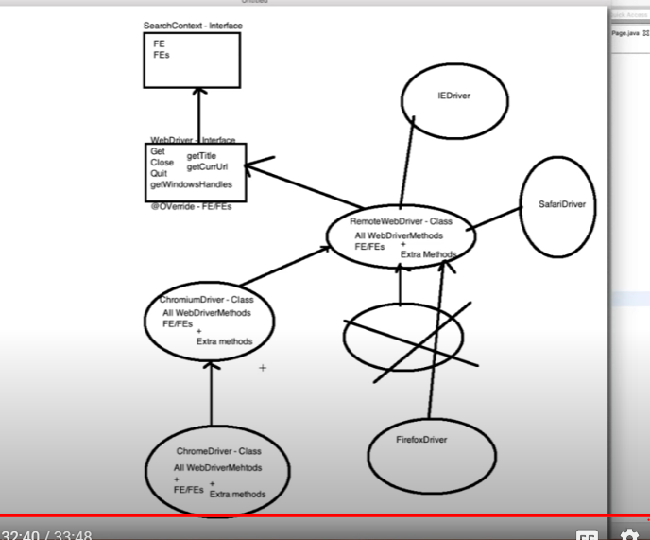

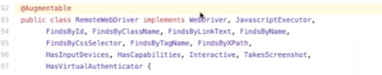

What Are The Main Traits Of A Software Test Automation Framework?

A test automation framework should have the following features.

* Flexible in the programming language selection
* Support of keywords and actions
* Provision of data sources for input
* Allow test case creation and modification
* Define test case priority
* Manual or automated execution
* Maintain test results history
* Generate test metrics such as test vs. code coverage
* Report creation
* CI tool integration such as Jenkins
* Cross-browser and cross-platform support

What Type Of Test Framework Did You Create Using Selenium?

We are using the hybrid approach where we use the data driven +page object model +page factory pattern with the concept of TestNG.

1. We have a page layer where every page has a java class where we define the locators and actions.
2. Base page where we are going to initialise the driver and read the properties
3. Config properties file where we have env variables like url, browser, username and password.
4. Test Layer where we have all the test scripts and the page layer separate with all the testing annotations, test classes with assertions / data providers etc.
5. Different lib/ utilities like dynamic waits(implicit, explicit,java utilities) apache POI excel ,xml util,Json util etc.This is how we design/test and integrate all these.
6. Then we have testNG runner where we combine the things in template and execute this.
7. Test data layer where we maintain excel or csv files
8. Generate reports like html reports, extent report, TestNG report, emailable report pdf reports and also generate different logs using log4j
9. Then design the entire framework with maven project maintaining the POM.xml file where we have diff dependencies like webDriverManager, TestNG API’s, cucumber, Apache POI,xml dependencies,Json dependencies.
10. Maintaining the maven lifecycle where we maintain diff plug ins like compiler, source, surefire(execute the test cases), jar/resource,reports
11. Finally moving to the git repository or bit bucket and push the code where we have PR(pull request ) process and then we have to run into Jenkins (CI -CD tool) which can be auto or manula trigger.
12. Or we can run all these on some cloud machine like AWS where we maintain the grid console through docker container.

My latest project in Hertz was about the upcoming automated car rental services which has a user interface that allows the customers to view the different cars available by price, model, seating, and other potential searches.

The basic module was where the user has the ability to register and log in to the Web app and track their rental plan.

The other services to the basic module was the upgraded services where the regular customers could upgrade to the speedy gold membership where they get extra benefits and more options to select the desired cars. The benefits include the premium emergency roadside assistance, personal protection, vehicle protection (When you purchase Loss Damage Waiver (LDW) or Vehicle Protection, you have no financial responsibility for loss or damage to the rental car.), liability protection etc.

Another module was Hertz reservation System for disabled(HRSD) which is about the car rental services for people with Disabilities where the rental experience is as easy and convenient as possible. A full range of service are available to both the registered customer and any guest member with physical disabilities. The basic services offered in this are hand controls, spinner knobs, Accessible parking, easy access bus etc. This system allows to identify the five different special needs: left hand controls, right hand controls, steering wheel spinner knobs, visual impairment, and customer with disability.

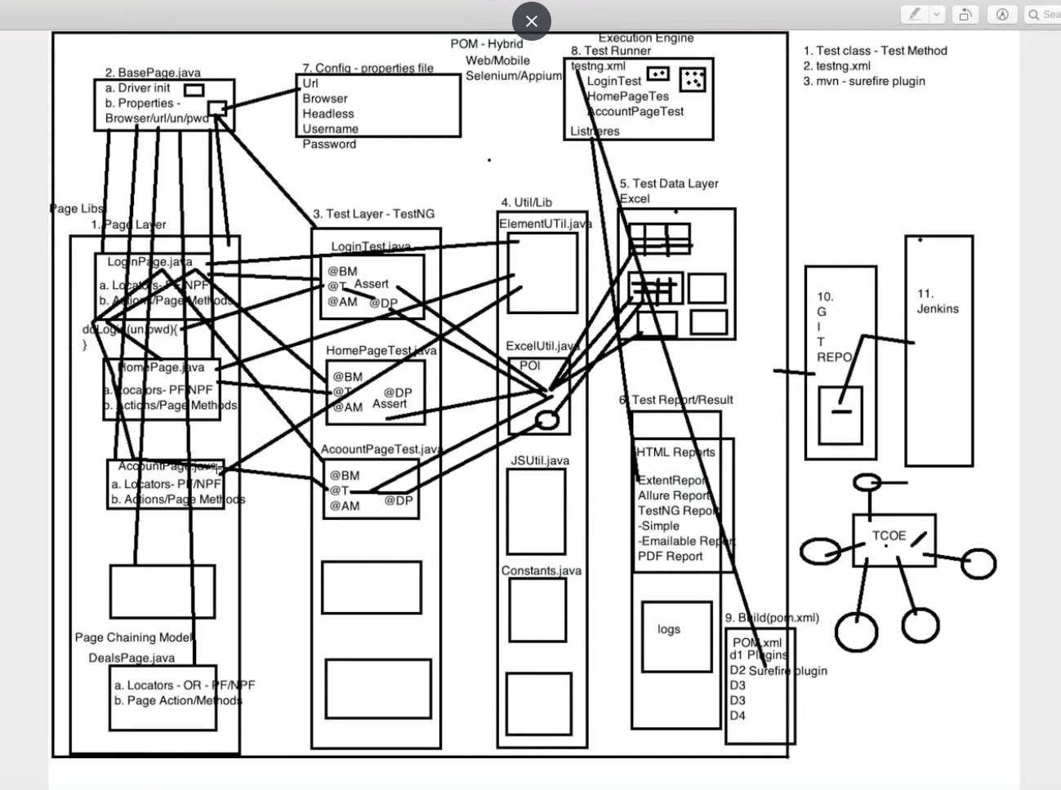

While replying to such questions, stay focused, and keep your answer short and crisp. You can start by telling about the different components in your framework and then explain them one by one.

Here is an illustration for your help.

* I worked on a framework built on top of the Page Factory framework.
* I’ve created a page class for every web page in my application. It keeps the objects and the handler functions.
* Every page class has a followup test class where I create tests for related use cases.
* I used separate packages to host the pages and their test classes. It’s a best practice to do that way.
* The framework also had a lib package for utility and some standard wrapper functions over Selenium APIs.
* Java is core programming language used for this project. It was primarily because the team had previous Java experience. Also, we could utilize the TestNG annotations and report features.
* Most test cases are data-driven. They require input from the external data source. So, I used Java property/POI class to read from the CSV/XLS files.
* We used the TestNG group feature for labeling test cases as P1, P2, and P3.
* The Log4J library provided the necessary support for tracing in our project.
* Instead of using the TestNG reporting, we preferred the Extent report. It has more graphical options and gives an in-depth analysis of the results.
* We built the framework with the help of Maven. Also, Jenkins provided support for automated build and execution.
* Bitbucket allowed us to manage our source code using git repositories.

What Are Challenges Have You Faced With Selenium? And How Did You Overcome Them?

Here are some of the problems that testers usually face while doing automation with Selenium.

* **Wrong implementation:** I used the [**page object model**](https://www.techbeamers.com/implement-page-object-model-pom-with-selenium-and-web-driver-2-0/) but had it implemented incorrectly because of the unawareness of the guidelines /rules and randomly implemented. My classes were focussing on the web elements rather than they should have resembled the user actions.
* **Duplicate code:** The project had many category pages. Each category had a different search function instead of handling them at a central place.
* **Ineffective use of wait:** I used implicit wait with a fixed timeout. But some pages were timing out due to higher load time. I had to adopt the Fluent wait (with a variable timeout) to overcome this problem.
* **Improper error handling:** It was getting hard to debug the cause of a failed test. At some places, the {try-catch} blocks were missing, and hence, cases were skipping w/o giving a proper reason. Therefore, I had to refactor the code by adding asserts and exception handling.
* **Inconsistent XPath:** Most of the locators were using the XPath method. And the developers kept them changed while fixing new defects. I called up a discussion with them and agreed to have a fixed XPath or an ID for the web elements.
* **Performance & Localization:** We were using the flat files (CSV) initially to feed data to test cases. However, it had us failed in testing localization as well as beaten us on the performance. we migrated all of our test data to MySQL and fixed both issues.
* **Monolithic tests:** Earlier tests weren’t using the labeling. Honestly, there wasn’t a way to do it. Hence, we integrated our test suite with TestNG and got away with this limitation. Now, we have many test groups like features-based(home group, search based, smoke test cases, sanity test cases, regression test cases (F1, F2, F3…), priority-based (P1, P2, P3).

X

Hertz :

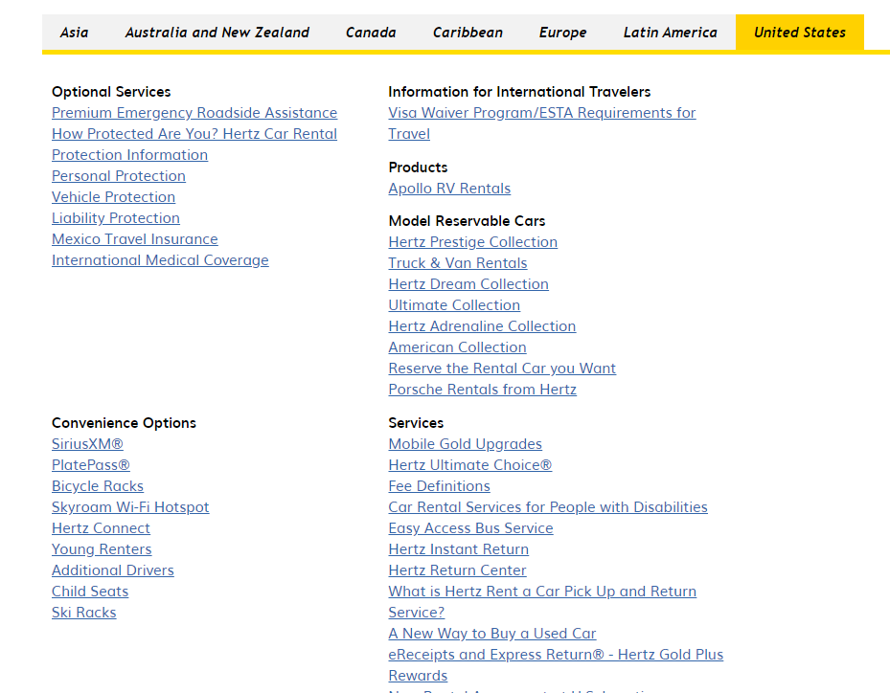

APPS TO learn :

SoapUI

REST APIs

Potsman

Swagger